Control Systems Lab

Lab 3 In-Class: Frequency Response

Objectives
- Investigate the output speed response to a sinusoidal input voltage to the DC motor
- Obtain data to construct the DC motor’s experimental frequency response (bode plot)

Simulink File
You will be using a Simulink file to command a sinusoidal input voltage. Settings that you may change for these experiments are ‘frequency’, ‘amplitude’, and ‘voltage offset’. A typical diagram is below:
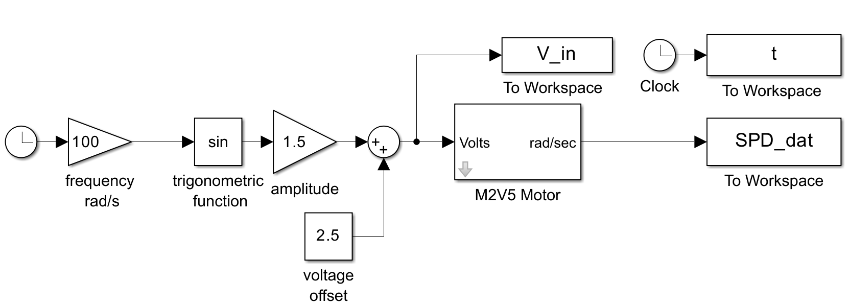
After you stop the file, the data will be stored in variables ‘V_in’ (input voltage), ‘t’ (time) and ‘SPD_dat’ (angular speed of the motor), in you MATLAB Workspace.

Characterizing the output response

- Open Simulink file, “M2V5_Motor_FrequencyResponse_CSL.slx”. Use a voltage offset of 0V and input frequency of 0.5 rad/s. Set the amplitude to 1.5 V. Press Monitor and Tune to run the program and watch the red disk carefully. After stopping the program, plot three cycles of SPD_dat vs t in MATLAB (properly labeled as per the course syllabus: with your name in the title, axes labeled). Upload an image of the plot to Gradescope. Notice the shape is not a normal sine wave - what physical behavior is causing this? (You do not need to save this data).

- Next, change the offset to 2.5 V, keep the amplitude as 1.5V, and set frequency to 30 rad/s. Restart the Simulink file and collect data long enough to collect at least three steady state cycles. Plot the input and output on the same plot using the sample code below.

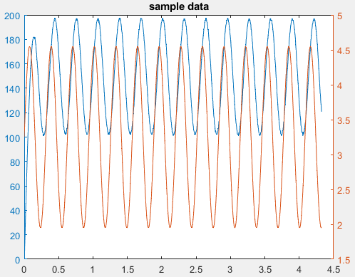
load lab3_test.mat
Figure 1: SAMPLE – might not match your data

yyaxis left
plot(t,SPD_dat)
ylim([0 200]) % adjust this
ylabel('speed (units)')

Next, adjust the horizontal axis limit to display 3 steady state cycles, and the vertical axis limits such that the input and output sine waves are approximately the same size. This will make it easy to measure the amplitudes and phase shift.
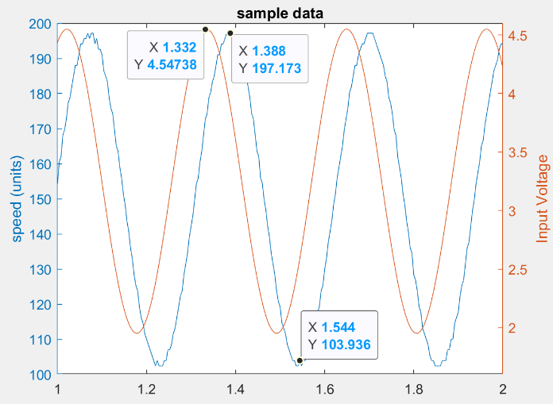
Figure 2: SAMPLE - might not match your data
load lab3_test.mat

yyaxis left
plot(t,SPD_out)
ylim([100 200]) % adjust this
ylabel('speed (units)')

yyaxis right
plot(t,V_in)
ylim([1.6 4.6]) % adjust this
ylabel('Input Voltage')

Finally, include proper labels (according to course syllabus: title with name in title, axis labels with units). Use ‘Data tips’ to mark the exact points you will be using to answer questions 3, 4, and 5 below (as shown in the figure above). Upload the plot to Gradescope.

- Calculate the offset in the output speed when the input has the specified offset.

- Use the data to calculate the frequency response magnitude for 30 rad/s. Note that peak-to-peak distance is easier to measure from a plot, but the amplitude is defined as centerline-to-peak. How does this compare to the prediction from the prelab bode plot (end of page 2)??

- Use the data to calculate the frequency response phase for 30 rad/s. You can start by estimating the shift in time between the input and output, then converting that to an angle. How does this compare to the prediction from the prelab bode plot (end of page 2)?

Collect data for experimental frequency response

- Write down a list of test frequencies you wish to collect to construct the bode plot. Submit your final list in Gradescope along with your reasoning. You may adjust your test frequencies based on feedback you got on your prelab assignment.

- For each frequency in your list, run the Simulink file (keeping offset at 2.5 V) for an appropriate amount of time, stop, and save data to a .mat file. Upload a screenshot of your MATLAB working directory showing all the .mat data files. The purpose is for you to verify you have saved all data you need at each frequency. A file explorer screenshot showing all your data files is also acceptable.

